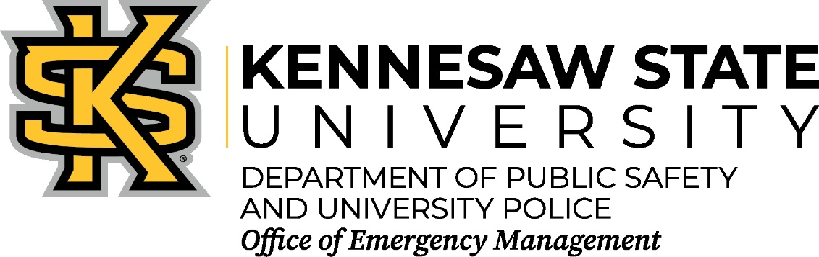

Online Emergency Management, Safety and Preparedness Training Opportunity

FEMA Independent Study
  - https://training.fema.gov/is/
  - The Emergency Management Institute (EMI) offers self-paced courses designed for people who have emergency management responsibilities and the general public. All are offered free-of-charge to those who qualify for enrollment. There are hundreds active courses that can be taken at the users own pace. Check back monthly for new courses being added. You just have an SID # to register for classes (it only takes a minute): https://cdp.dhs.gov/FEMASID
- Georgia Public Safety Training Center online classes
  - https://access.gpstc.org/student/classes/public-catalog?f=ONLINE
  - Many of the free online classes are for professional public safety staff, but other classes provide excellent opportunities to others who want to learn more about ways to keep the community safe.

National Center for Disaster Preparedness
  - http://ncdp.columbia.edu/practice/training-education/online-face-to-face-training/
  - FREE online certificate training courses, webinars, and lectures designed for individuals working in health systems including, but not limited to: health care, public health, home health, Medical Reserve Corps (MRC), community health, regional learning centers, and emergency management. All of the CRLC’s certificate courses are developed based on CDC Public Health Preparedness and Response Competencies and Public Health Emergency Preparedness Capabilities.
    - All Courses are FREE.
    - Most courses have multiple lessons which allow a learner to complete a course at their own pace. However, each lesson must be completed in order.
    - After completing a course including passing the post-test and course survey, you will automatically receive an e-mail containing a certificate of completion.
    - If this is the first time visiting the CRLC site, you will need to register as a user by setting up a username and password. Use this information to log-in each time you visit.
    - This site tracks activity and keeps records of courses completed and in progress.

SLATT (State & Local Anti-Terrorism Training) Program
  - https://www.slatt.org/SLATT/Online_Training
  - SLATT offers online training modules to provide law enforcement practitioners with an introductory-level training of terrorist and violent criminal extremist core concepts and an understanding of terrorist ideology and tactics. Sessions include pre-incident indicators, terrorist/criminal extremist groups, Arabic culture, intelligence issues, and case studies.

- Association of Public Safety Communications Officials (APCO)
  - https://www.apcointl.org/training-and-certification.html
  - APCO offers a variety of training courses tailored for the public safety communications profession that are available in classrooms and on line. Most, if not all, of the APCO training courses have a registration fee and some have prerequisites, so play close attention to these when signing up for courses.
- Center for Homeland Security and Defense
  - https://www.chds.us/c/academic-programs/self-study-courses
  - The Naval Postgraduate School Center for Homeland Defense and Security offers non-credit, self-study courses online. These courses are developed by the NPS CHDS teaching faculty and are derived from course content (lecture material and course readings) from the Center’s homeland security master’s degree curriculum. The courses, offered at no cost, are designed for homeland defense and security professionals who wish to enhance their understanding of key homeland security concepts and require the flexibility of self-paced instruction. NPS does not provide graduate credit for the courses; however, participants are encouraged to check with their professional associations regarding continuing education units/credits. Access is granted to local, tribal, state and federal U.S. government officials; members of the U.S. military; corporate homeland security managers or contractors; homeland security researchers or educators; and students currently enrolled in homeland security degree programs.
- Alison
  - https://alison.com/
  - A wide variety of online classes that includes several on public health, food safety, etc. Most of these classes require you to purchase your certificate, but there are a number of free online classes as well.
- Online Videos
  - How to Use the 2016 Emergency Response Guidebook (ERG) (20 minutes)
https://www.youtube.com/watch?v=WCpr4Xmhrss The Pipeline and Hazardous Materials Safety Administration has developed a free, mobile web app of its Emergency Response Guidebook 2016 (ERG). The new safety tool provides the nation's emergency responders with fast, easily accessible information to help them manage hazardous material incidents. This software is available from the Apple iTunes store for iPhone, and from the Google Play website for Android. This short video also includes important Safety Precautions when responding to a hazmat incident.
  - Run. Hide. Fight. Surviving an Active Shooter Event (6 minutes)
https://www.youtube.com/watch?v=5VcSwejU2D0
- CERT Training Videos
https://www.fema.gov/media-library/multimedia/collections/484
A variety of videos including how to put out a fire, disaster psychology, head-to-toe assessments, etc.

